**Shoulder and elbow pain**

**Initial Assessment**

|  |  |  |
| --- | --- | --- |
| **Presenting Symptom/Chief Complaint** | | |
| Patient had been suffering from pain of the left shoulder point and it extended to left elbow along the lateral side of the left arm. | | |
| **Main Signs and Symptoms** | | |
| Feeling cold all the time, tiredness. Shoulder is very stiff and arm difficult to abduct. | | |
| **Other Signs and Symptoms** | | |
| She is overweight**.** Pale purplish tongue. Low energy especially at the end of the day. Pain worse in cold rainy condition elevating with heat. | | |
| **TCM Diagnosis and Treatment (identified TCM disease, TCM differentiation of syndromes)** | | |
| Cold painful obstruction syndrome of the left shoulder with underlying Yang deficiency. Internal cold. | | |
| **Treatment Principles and Strategies** | | |
| The treatment principle adopted to expel cold wakens the LI channel on the left side and tonify the Jang of the body. | | |
| **Treatment Plan (Modalities; acupuncture, herbal, dietary, manual therapies), frequency and duration** | | |
| Acupuncture with warming needling tonification of local points involved LI, SI**,** TW channels. Acupuncture session 2-3 times a week for 1 hour till the symptoms resolved. | | |
| **Any other Advice Given to Patients** | | |
| Acupuncture: LI 15 (L), GB 21 (L, R) Extra point (as local points**)** LI 1 (L) to remove obstruction from LI channels alternated with TW8 (group LO point of 3 Yang Area channel to ↑ QI flow in the 3 Yang channels. Tender points: SI 9 (L), SI 11 (L), SI 13 (L), TW 15 (L). The treatment need the tonifing method with warming needling and exercises of the arm and shoulders for the resolvement of elbow pain use.  LI 4 (L;R) points with sedation and LI 11 with tonification. Acupuncture of 1 hour. | | |
| **Practitioner:** | **Date:** | **Signature:** |

**Daily Charting____________________________________Patient Name:_________________________**

**Date:________________**

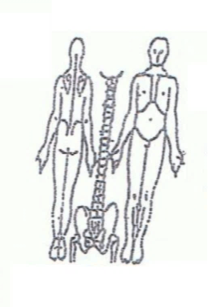 **Working Diagnosis:**

Cold painful obstruction syndrome to the left shoulder, left elbow.

S: Yang deficiency and internal cold**.** Complaining of pain at the left shoulder area. Radiating down the arm area over left elbow. At times pain also extended to the left scapula, pale purplish tongue, sleeping difficulties. Difficulties in abduction the left arm.

O:

Treatment (P) Acupuncture with main tonification of the local points for 1 hour LI15

(LR SI14 – SI11)

(A)

**Date:________________**

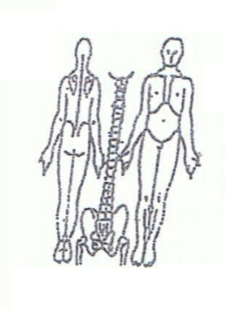**Working Diagnosis:**

S: Patient is still have the feeling cold and pain with the movement of left arm, ROM N. Pain still 4-5 on the pain scale 1-10. Difficulties sleeping, tiredness.

O:

Treatment (P) Acupuncture with Moxa on the GB channel, Li channel with Moxa for

1 hour

(A)

**Date:________________**

**Working Diagnosis:**

S: Patient feeling more energized, better appetite, better sleep. Feeling warm and comfortable during the day. Pain , ROM. No radiation to the pain to scapula and elbow.

O:

Treatment (P) Continue 1 hour acupuncture needling + Moxa. Start exercises 5 min.

(A)

**Date:________________**

**Working Diagnosis:**

S: Patient much happier. No ROM limitation. N sleep. No pain. Start normal daily activities. Exercises - 20 min daily.

O:

Treatment (P) Acupuncture with tonification over L1, St, Lu, H channels 1 hour.

(A)